Problem Statement: AI-Based Real time Stress and Trauma assessment module for victims/complainants accessing NHAA(14566) and Integrated Portal
Sr No: 93
Ministry of Social Justice and Empowerment (MoSJE)
Type: Software
SIH Id: SIH26093

The Main Logic behind this Problem Statement:
- Victims or complainants accessing a grievance-redressal system may experience significant emotional stress while reporting or following up on an incident.

- The National Helpline Against Atrocities (NHAA), available through 14566, was established to facilitate grievance redressal and awareness regarding legal protections for SC/ST communities. The system also supports complaint registration and tracking.

- PS 26093 proposes adding an AI-based real-time stress and trauma assessment module to the NHAA integrated portal.

- The purpose would be to identify indications of emotional distress during the interaction and provide appropriate supportive responses or escalation to human assistance.

- Why does this problem exist?
- Victims may experience emotional distress .
- The complaint process can be stressful.
- Existing grievance system primarily focus on the complaint.
- Need for timely identification.
- Large – scale accessibility.

- Main causes of stress and trauma in this context
- Experience or discrimination or atrocity.
- Fear or insecurity after an incident.
- Harassment, intimidation or social pressure.
- Difficulty communication the incident.
- Concern about receiving justice or protection .

This is a Important Part of Problem Statement
- Proposed solution-
propose an AI-powered assessment module integrated with the NHAA portal.

Basic workflow:
Victim/Complainant → NHAA 14566/Portal → AI Assessment → Stress Indicator → Appropriate Support/Escalation → Human Officer.

The module could analysis permitted interaction data and use an assessment model to identify possible indicators of distress.

The system could then:
- Assess the user's reported emotional state.
- Generate a non-diagnostic stress/trauma indicator.
- Alert or recommend human intervention when appropriate.
- Provide supportive information and guidance.
- Maintain privacy and security of sensitive information.
- Allow authorized personnel to monitor relevant cases.

The AI should not be presented as a medical or psychological diagnosis. It should function as an assistance and early-identification tool.
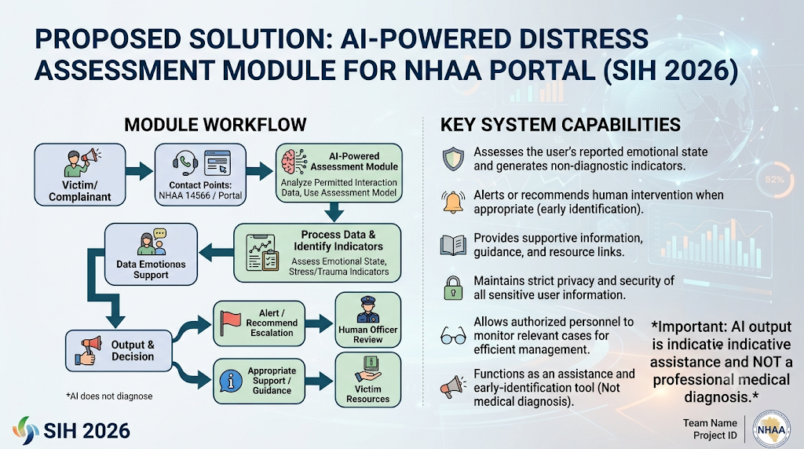

- Benefits of the project

- Better victim support.
- Early identification of distress.
- Improve grievance experience.
- Better prioritization .
- Smart automation.
- Scalable solution.
- Multilingual potential.

- Why should we choose this problem statement
- Strong social impact
- Strong smart automation connection
- Good demonstration potential
- Can be built as a working prototype

- Expected impact

- The proposed system can add a human-support layer to an existing grievance-redressal ecosystem.

- Instead of viewing a complaint only as a case to be registered and tracked, the system could also recognize that the person submitting the complaint may require appropriate support during the process.

- NHAA already provides grievance redressal and tracking, and government sources report substantial usage of the helpline.

- As of July 30, 2025, the government reported 6,34,066 calls received through NHAA.
This demonstrates why an additional intelligent support mechanism could be meaningful at scale.

- Conclusion –

- PS 26093 is a strong Smart Automation problem statement because it combines AI, software engineering, social impact, government services, and human-centered technology.
- Our team should consider this topic because it provides an opportunity to develop a practical prototype that does more than automate a routine task.
- It aims to make an existing grievance system more responsive, intelligent, accessible, and supportive while keeping human officials involved in important decisions
Reference: Hackathon report(Richa and Saiyadri)

